**Guy Fawkes**

## Lesson plan

***Remember, remember the 5th of November,***

***The Gunpowder Treason and Plot***

***I see no reason why Gunpowder Treason***

***Should ever be forgot***

**Class: 4th grade**

**Time: 1 period**

**Step A (5 min)**

Fast pupils (18 in number) work in pairs on a Halloween crossword for vocabulary consolidation (Appendix 1, worksheet 1). Slow and medium learners form a group and work on WB p44 ex2 Halloween-correct the mistakes- with PB p62 open. Teacher moves around the groups/pairs to provide support where necessary. Next, teacher picks up pupils’ worksheets/WBs.

**Step B (10 min)**

**Warm up:** Teacher gives brief info about November 5th. Pupils do in pairs the gap filling activity in the school manual (PB, p65, ex. 5) T eacher writes new vocabulary (+from the video that follows) on the whiteboard. (Appendix 2, Glossary)

**Step C (6 min)**

Pupils watch the video: <https://www.youtube.com/watch?v=q1DC2BAsXb4>

**Step D (15 min)**

Pupils work in pairs on worksheets 1, 2, 3 according to their learning profile. Slow learners copy the rhyme from the whiteboard and work on the coloring page (Appendix 3, worksheet 1), medium learners do the word search activity (worksheet 2) and fast learners build words (worksheet 3).

|  |  |
| --- | --- |
| **APPENDIX 1**  **Worksheet 1** | D:\2dgraphics\halloween.jpg |
|  |
| D:\clipart-arttoday\halloween\pumpkin3.jpg |
| **Across**  **3.** A funny costume.  **5.** What do you wear on your face?  **6.** _____-or-treat!  **8.** Scary thing that says boo.  **10.** Roasted pumpkin _____.  **11.** Small black animal that can fly.  **12.** Kids get lots of this. | **Down**  **1.** A monster with many bandages.  **2.** ____-o'-lantern  **3.** What do you wear on Halloween?  **4.** A woman with a pointy black hat.  **7.** A witch's pet.  **9.** spooky |
| **D:\clipart-arttoday\halloween\skeleton.jpg** | Name that monster:  A __________ is a monster that changes shape during the full moon.  A __________ is a monster that is made from bones. |

**APPENDIX 2**

**Glossary**

Parliament: κοινοβούλιο

plot: συνωμοτώ, σχεδιάζω

gunpowder: μπαρούτι

treason: προδοσία

traitor: προδότης

Catholic: καθολικός (θρησκεία)

Protestant: προτεστάντης (θρησκεία)

guy: άνθρωπος

firework: πυροτέχνημα

bonfire: φωτιά για γιορτή

explosion: έκρηξη

explosives: εκρηκτικά

**APPENDIX 3**

**Worksheet 1**

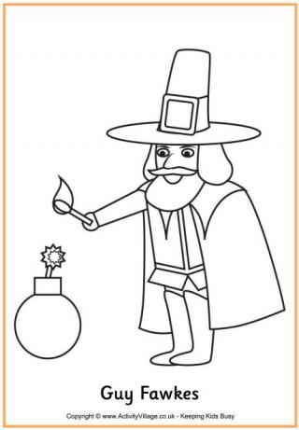

**Worksheet 2**

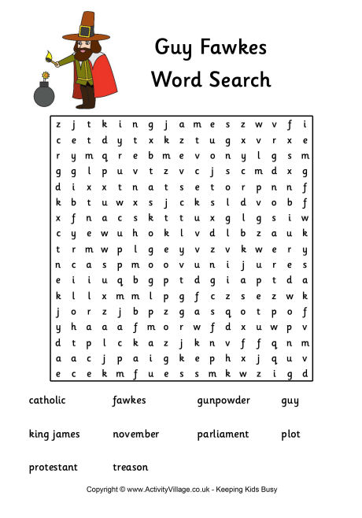

**Worksheet 3**

