Countless flood disaster caused by the river Evros. Many houses and fields were flooded, the farmer’s production was destroyed, residents were trapped in their homes and many of the animal’s livestock drowned. 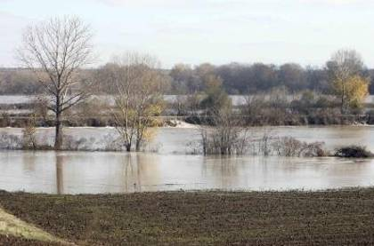
Helen Batzi ST’1

